10th International Geography Olympiad

Kyoto, Japan

30 July – 5 August 2013

Written Response Test

Marking Scheme

Instructions for the Markers

1. Check if the iGeo Student Numbers are on each sheet before dividing up the paper.

2. This test consists of 6 Sections.

3. One whole Section per marker and double-checker.

4. Check whether the answer continues outside designated area.
No credits will be given to answers in the Resource Booklet.

5. The maximum total mark is 90.
The mark for each question is given at the beginning of the question.
There are a maximum of 15 marks for each Section.

6. Get the hang of the full range of answers by reading through a few papers with your co-marker before you start your marking.

7. These answers are not exhaustive. Credit any relevant answer.

8. Mark only the required number of answers (reasons, examples, etc.).
For instance, if the question asks for 2 reasons and there is more than 2, only the first 2 reasons will be marked.

9. Put your mark next to the question number in the column on the left – it eases the work of the person who has to put the numbers into MS Excel.
Total the marks by the title of the Section.

10. Usually whole marks with only these exceptions: A1, B1, C3, E6.

11. The Moderators (Sue and Anu) will sample the marking of all teams.

Section A: Tourism and Conservation

3m 1. Study the Diercke International Atlas (later on referred to as the Atlas) pages 196–197 map 1 “Tourism”.
Identify the 3 main areas of the world where tourism is important because of the relative number of visitors to the number of inhabitants according to the map key.
Suggest reasons why these areas attract so many tourists.

Area 1: ................................................ Reasons:

Area 2: ................................................ Reasons:

Area 3: ................................................ Reasons:

Answer: 3 marks: 6 x 0.5 marks: maximum 1 mark for each area which must include at least 2 reasons.
Area 1: Europe:
- The range of tourism (reasons for travelling from the map key: city, cultural landmark, winter sports, beach holidays, national park, natural landmark, pilgrimage centre, round trip, safari, trekking, cruise),
- Densely populated but lots of tourists affluent enough to travel,
- Time to go on holiday,
- Tourism tradition.
Area 2: Caribbean or West Indies:
- Close to North America so source of visitors,
- Hot weather and beaches,
- Quite cheap local costs,
- To experience different cultures (rum, rasta, reggae, ska, voodoo, cigars, Pirates of the Caribbean) and natural heritage.
Area 3: Indian Ocean islands:
- Global marketing of an ideal location for holidays/honeymoons,
- Hot climate,
- Long sandy beaches,
- Easy access by air from Asia/Europe,
- Remote, secluded, escapism.

4m 2. Study the Atlas pages 56–57 maps “Europe – Tourism”, especially map 3 “Albir and Benidorm – Different types of tourism”.
Compare and contrast the tourist resorts of Albir and Benidorm.

1:

2:

3:

4:

Answer: 4 marks: 1 mark for each comparison or contrast involving both Albir and Benidorm.
- Albir is made up of apartment and low-rise bungalows probably all about the same age whereas Benidorm has a varied land use.
- A few hotels in the north around promenade Calle de los Músicos in Albir whereas Benidorm has mainly high rise hotels.
- Albir doesn’t have any public buildings, except for a hospital. It’s just a primarily summer recreational residential area, vacation village whereas Benidorm has a range of public buildings and tourist locations, e.g. library, castle, bullring, hospital, harbour developments, Aqualandia (map 2).
- Main residents of Albir are likely to be family or older couples because of golf course in Albir whereas in Benidorm there will be local people living there as well as tourists.
- Albir has winding roads similar to suburban developments trying to give interest whereas Benidorm possesses quite regular angular street network.
- Benidorm has its own water sports harbour whereas Albir people have to go to Altea.
- Both have a high number of swimming pools, beaches, tourist information centres, campsites which show they are tourist areas.
- Both have quite a lot green space around residential areas.
- Both have good connections to railway and roads (map 2) to other inland tourist attractions as well as highways to Alicante and Valencia.

3m 3. Describe the goals of ecotourism.

1:

2:

3:

Answer: 3 marks: 1 mark for each goal of ecotourism even if the 3 recognised aspects of ecotourism are not clearly spelled out but are fully explained.
- Conservation of fragile natural (and cultural) areas; limiting the numbers of visitors; seasonal management; providing direct financial benefits for conservation.
- Sustainability – low impact on natural (and cultural) environment in destination by small scale activities so that future generations may experience destinations relatively untouched by human intervention; promotion of recycling, energy efficiency, water conservation; awareness, education and respect; responsible travel and accommodation.
- Improving the well-being of local communities and empowerment for indigenous people; employment; benefit by income generation via buying e.g. local goods; more fostering of respect for different cultures and human rights than conventional (mass) tourism.
5m 4. To what extent are protected areas (e.g. national parks) effective in the conservation of natural environments?

Answer: 5 marks: maximum 3 marks if they discuss only positive or negative effects.
Positive:
- Zoning can protect particularly fragile species/areas,
- Limit development and exploitation of natural resources, e.g. forest,
- Protection of natural ecosystems,
- Provide jobs and business opportunities for indigenous and local people; by giving local people a vested interest in the protected area, they help preserve it,
- Raising awareness of issues to do with conservation through education,
- Raising income from visitors’ fees to contribute towards the management of the area,
- Making it easier for people to access natural environments and appreciate them more can result in pressure to conserve natural environments.
Negative:
- The cost of fuel to travel and pollution caused by vehicles travelling around the area,
- They provide honeypot sites which attract more people to them. NB! This can also be treated a positive if students explain that it concentrates visitor damage in one area so other areas remain pristine,
- Areas can’t protect against external factors, e.g. climate change and pollution,
- Some countries don’t have the financial resources to manage their protected areas, e.g. can’t stop poaching, control feral special,
- Some countries don’t have the political will to manage protected areas properly, e.g. stopping local people grazing animals.

Section B: Volcanoes and Tectonic Activity

3m 1. Study Resource Booklet Sources B1–B3 pictures of the volcanoes.
In the table below name the types of volcano in the 3 photographs and in a few words describe the tectonic conditions under which each volcano was formed, using the Atlas pages 174–175 map 1 “Plate tectonics, volcanism and earthquakes”.

Answer: 3 marks: 6 x 0.5 marks.
 | Haleakalā | Merapi | Surtsey
Volcano  type | Shield volcano | Strato volcano or composite volcano | Strato volcano or composite volcano
Tectonic  conditions | (Old) hotspot | Plate descends (oceanic trench with subduction) or convergent plates with subduction | Plates drift apart (oceanic ridge) or divergent plates with new ocean floor material

2m 2. Explain the difference in shape between the volcanoes of Haleakalā and Merapi.

Answer: 2 marks.
- The Haleakalā is formed by less violent eruptions where more fluid lava or basic lava spreads out creating a gently sloping volcano that covers a large area.
- The shape of Merapi is the result of more explosive eruptions. The lava is more viscous or acid and the steep cone is built up of layers of lava and pyroclastics (ash, cinders and bombs).

3m 3. Which of the 3 volcanoes in the pictures will probably pose the biggest threat to people and the environment in the near future? Give reasons for your choice.

Answer: 3 marks: 1 mark for choosing Merapi, 1 mark for people (human) related reasons, 1 mark for environmental (physical) reasons.
Reasons related to human features:
- The Island of Java is one of the most densely populated areas of the world while the island of Maui is not as densely populated. No habitation on Surtsey.
- The people live very near the very active volcano, there is big city located near the Merapi, Yogyakarta.
Reasons related to physical features:
- The strato volcanoes erupt more violently, throwing out steam, gas and lava bombs than the Hawaiian shield type.
- The Merapi is more an active/young volcano while Haleakalā is not located on an active hotspot any more.

2m 4. Study Resource Booklet Source B4 picture of the volcano.
Describe the different phases of volcanic activity of the area in the photograph.

Answer: 2 marks for describing the 2-phase history.
- The photograph shows an area where volcanoes have formed over time. In the past a build up of pressure has resulted in a violent eruption which has blasted out previous cones leading to the formation of a caldera, the edge of which can be seen in the photo.
- Continued volcanic activity in the area has resulted in a new cone forming inside the caldera.

2m 5. Outline 2 ways in which scientists try to forecast volcanic eruptions.

1:

2:

Answer: 2 marks.
Scientists monitor and measure changes in the environment around the volcano:
- Seismic activity – the movement of magma results in minor earthquake activity.
- Ground deformation – as the magma rises the ground swells up and slopes change.
- There is increased discharge from hot springs/melting of snow on the volcano.
- Increased SO₂ or CO₂ emissions from the vent.

3m 6. Explain why some people live on the slopes of active volcanoes.

Answer: 3 marks.
This should not just be a list. Students should explain why people live in these areas. They may contrast developed and developing world countries.
- Fertile soils mean that it is efficient to grow food crops and cash crops.
- The area is densely populated and there is nowhere else to go to provide a living.
- They believe that warning systems will allow them to evacuate the area.
- Traditions, roots, nostalgia, links to family.

Section C: Managing Urban Areas

4m 1. Study the cartoon which makes a comment on the process of urban sprawl.
Explain the causes and the consequences of urban sprawl.

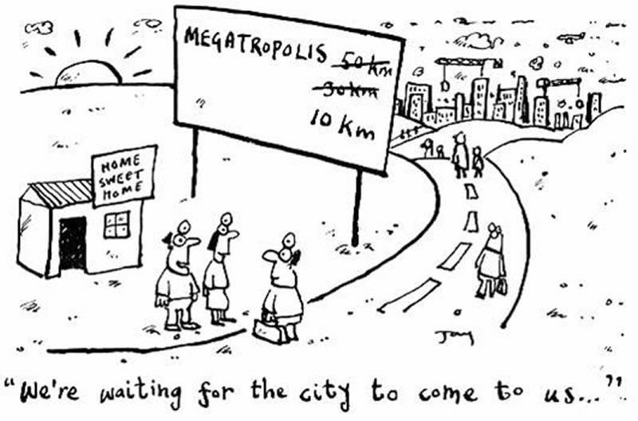

Answer: 4 marks: maximum of 2 marks if only causes or consequences are addressed.
Causes – centrifugal population movement due to push and pull factors:
- Push: congestion and high land values in the city centre mean that people want to move out.
- Pull: open space, cleaner air, less congestion and cheaper land at the rural-urban fringe or beyond.
- People attracted to the city live in the suburbs rather than the city centre because it is too expensive to live in the centre.
- People who have lived in the centre move to the suburbs for larger accommodation, more open space, greater safety.
Consequences – increased commuting, traffic congestion, pollution and stress if this movement is spontaneous, unplanned and on a large scale.
- Costs of (government-provided) infrastructure (e.g. water, public transport) are greater in the lower-density fringe.
- Isolation, e.g. young mothers moving away from family support structure.
- Changes in fringe land uses if farmers sell land for housing developments through diversification.

6m 2. Outline the effects of urban structure upon microclimate in the urban area.

Answer: 6 marks.
Temperature | Wind | Humidity
Buildings absorb heat during the day and release it at night | Average wind speed in cities is reduced by friction with the rough built-up surface | Impermeable urban surfaces absorb heat due to low albedo (tarmac) and have little water storage capacity and are therefore drier
They also produce anthropogenic heat from artificial heating in winter and air conditioning in summer | Narrow streets funnel winds along them causing eddies and the ‘canyon effect’ | Urban areas are often short of vegetation resulting in less evapotranspiration and reduced relative humidity in comparison to the surrounding rural area
The warming effect is intensified by tall buildings closely packed in the city centre | Local wind speeds can be high which can cause localised cooling
City size is important and large high rise / high density cities such as Tokyo have a large thermal footprint than an African city such as Lagos, where less dense structures reduce the intensity of the urban heat island effect | Paris and many Middle Eastern cities have been designed with a radial street pattern to allow fresh air to be drawn in from the urban perimeter

5m 3. Identify and discuss 2 ways in which management practices could make urban areas more sustainable.

1:

2:

Answer: 5 marks: maximum 2 marks for a list.
The principles of sustainable urban management include providing:
- Economic security – people should have access to employment and an adequate livelihood,
- Housing – this should be healthy, safe, secure, affordable and within a neighbourhood that provides piped water, sanitation, drainage and transport,
- Health care provision – universal education, and child welfare,
- Resource conservation – by reducing consumption of fossil fuels in housing, commerce, industry and transport and substituting renewable resources where possible,
- Clean water supply – cities should draw on water resources up to their maximum sustainable yield and not beyond,
- Waste minimisation, recycling, reuse and reclamation,
- Conservation of cultural, architectural, historical and natural assets,
- Green space such as urban parks and playgrounds – ‘The Green Agenda’
- Reclamation, refurbishment or rebuilding on existing inner urban sites – ‘The Brown Agenda’.
- Active involvement of local communities in the processes of improving their local neighbourhoods.

Section D: World Energy Production

2m 1. Study Resource Booklet Source D1 the map showing world distribution of electricity produced from gas.
Describe the pattern of global electricity production from gas as shown on the map.

Answer: 2 marks: 1 mark for describing the general pattern, 1 mark for exceptions in the general pattern.
- USA, Europe, Asia and north Africa produce a lot more electricity from gas than South America, Australasia and sub-Saharan Africa.
- Some countries produce relatively large amounts within these areas e.g. Japan, UK, Norway and Italy. Countries such as Brazil, Canada and Argentina produce relatively small amounts of electricity from gas.

2m 2. Why do shale rocks often contain gas deposits?

Answer: 2 marks.
Shale is a sedimentary rock. In some sedimentary rocks plants and tiny sea animals were buried within the sediment that formed the rock, and were then changed by heat and pressure into oil and gas.

2m 3. Study the textbox below on ‘A New Resource’.
Why is the extraction of shale gas by fracking more difficult than conventional gas extraction?

A New Resource

The use of new technology has revealed that there are large reserves of natural gas in shale rocks. In the United States shale gas has become an increasingly important source of natural gas since the start of this century, and interest has spread to potential gas shales in the rest of the world. In 2000 shale gas provided only 1% of the natural gas production in the United States; by 2010 it was over 20%.

The conventional gas resources are much easier to extract compared to shale gas. The use of a new technique, called fracking, has increased the possibilities of shale gas exploitation. With the use of explosives, cracks are made in the shale at depths of up to 3 or 4 kilometres. Afterwards water, sand and chemicals are pumped into the boreholes. The sand fills the cracks and keeps them open. After the water is pumped away, gas will flow out of the shales. From one borehole gas can be extracted from the nearby shales. But the boreholes eventually have to be relocated to another area.

1:

2:

Answer: 2 marks: 1 mark for each well explained answer, not just a list.
- It is expensive to keep drilling new boreholes to extract the gas.
- It is more complicated to extract the gas from within the rock rather than from a reservoir on top of it.
- The number of vehicles/pipes required to bring in the water and remove the waste liquid.
- The use of explosives to create the cracks is expensive and causes concern.
- The shale gas is usually at greater depth than conventional natural gas.

2m 4. Study Resource Booklet Source D2 the block diagram showing the fracking process.
Give 2 possible impacts on the environment of increasing shale gas extraction.

1:

2:

Answer: 2 marks.
- In fracking they use chemical fluids that can pollute water reservoirs and aquifers.
- In shale gas exploitation they have to use more drilling locations than in traditional gas exploitation.
- Fracking can cause a disturbance of the stability in the earth layers, so there is a risk of earthquakes and landslides.
- Amount of traffic created by lorries bringing water and taking away gas.

2m 5. Give 2 reasons why countries in South America, such as Venezuela and Brazil, might not have the exploitation of shale gas as a high priority.

1:

2:

Answer: 2 marks.
- These countries have high potential for water power electricity (large river basins, large amounts of water are transported in rivers), there are large areas with big differences in altitude.
- These countries have their own large national oil or coal reservoirs and production.
- These countries have a large potential for biomass energy production from forests and other sustainable energy sources such as solar and wind power.

2m 6. Give 2 reasons why some Western European countries are particularly interested in shale gas exploitation in addition to conventional energy production?

1:

2:

Answer: 2 marks.
- These countries are for a large part dependent on the import of oil, gas or electricity out of regions with unstable political situations e.g. Middle East.
- These countries consume more energy than they can produce from their own national energy reserves.
- The use of gas to produce energy causes fewer CO₂ emissions and other pollution than the use of coal.
- Large scale open cast coal mining causes more damage to the landscape then local drillings.

3m 7. Discuss ways in which governments can reduce the amount of energy used in their countries.

Answer: 3 marks.
This answer should be written as a discussion not as a list of points. The following may be some of the points they introduce into their discussion.
- They can put taxes on less efficient types of fuel to make it more expensive for people to use.
- They can subsidise/fund research into the production of more products that use fuel more efficiently, e.g. cars, fridges.
- They can subsidise public transport to reduce the number of car journeys.
- They can subsidise freight rail transport as it uses much less energy than trucks to move the same amount of goods.
- They can fund research into designing houses with passive heating and cooling and subsidise their building.
- They can fund research/subsidise the development of more energy-efficient industrial processes, e.g. more efficient aluminium smelters.
- They can subsidise the cost of more efficient energy types for consumers at the point of sale.
- They can fund research into more efficient fuel types.

Example answer

Governments can use incentives to encourage consumers to use more efficient forms of energy by subsidising their production e.g. energy efficient cars.
They can fund research into the production of more products that use fuel more efficiently, e.g. fridges or they can legislate against or ban items that use energy inefficiently e.g. light bulbs.

Section E: Climate Change in Sudan

3m 1. Study the Atlas pages 176–177 map 4 “World climates – Effective classification according to A. Siegmund and P. Frankenberg”.
Give 3 reasons for climatic differences between Juba (southern Sudan, now known as South Sudan) and Cuzco (Peru).

1:

2:

3:

Answer: 3 marks.
Numeric characteristics (e.g. altitude: Juba 460 m and Cuzco 3,312 m) are not mandatory.
- Latitude: Juba is closer to the Equator than Cuzco (so average temperature in Juba is warmer than Cuzco).
- Altitude: Juba is much lower than Cuzco (so average temperature in Juba is warmer than Cuzco).
- Ocean currents: Cuzco is influenced by Humboldt’s (Peru) cold Current, while Juba may be influenced by warm current (Northern Equatorial Current) in the Indian Ocean, although the Ethiopian Highlands may block this effect to some extent.
- Pressure system: the annual shifting of the Inter-Tropical Climate Zone (ITCZ) to the Northern hemisphere from April till October with southerly and southwesterly winds leading to slightly lower temperatures, higher humidity, and more cloud coverage causing more precipitations in Juba while it is drier in Cuzco and vice versa.
- As can be seen in Source E2, Sudan is actually warmer in the north, i.e. further away from the Equator, so some explanation relating to influences from the northern desert climate warming the temperature may be acceptable.

3m 2. Study the Atlas pages 178–179 Map “The world – Ecozones/vegetation”.
Explain how the different ecozones/vegetation types surrounding Juba and Cuzco are influenced by the climate.

Juba:

Cuzco:

Answer: 3 marks.
 | Ecozones | Impact of climate on vegetation
Juba | 1. Dry savanna  2. Moist savanna | Annual temperature is high, so moisture is not enough for forest growing
Cuzco | 1. Monsoon forest and rain forest  2. Moist forest (cloud forest)  3. Steppe and mountainous grassland | 1. Temperature is lower, ratio of moisture and temperature is enough for the forest.  2. Temperature is too low for forest so get steppe/grassland above the forest

2m 3. Study Resource Booklet Source E1 graph showing climate aspects of southern Sudan.
The rise in average air temperature could be used to support the argument for global warming.
Suggest 2 reasons why people might oppose this view, using the graph.

1:

2:

Answer: 2 marks.
- There is nothing in the graph to show that the rise in the air temperature is outside the range of usual climate variability.
- In order to make sound conclusions in climatology usually 30 year cycles are used; the graph is only showing the change over 20 years.
- The graph presents no proof that this change in climate is human induced which is the main argument of global warming.

2m 4. Study Resource Booklet Source E1 graph showing climate aspects of southern Sudan.
The decrease in evapotranspiration is greater than in rainfall.
Why in very warm regions can increasing air temperatures reduce evapotranspiration?

Answer: 2 marks for a well developed answer.
As already high temperatures rise, the environment becomes less hospitable to plants, leading to less biomass causing less transpiration.

3m 5. Predict the consequences for local farmers as a result of this climate change in southern Sudan.

Answer: 3 marks.
- Drought, crop yield reduction, lessened food production,
- Pasture/land degradation,
- Decreased incomes,
- Food insecurity, famine, poverty,
- (Instability in the area).

2m 6. Study Resource Booklet Source E2 the climate change maps of Sudan.
Using the black-and-white maps below:
- Sketch on Map A – your prediction for the location of the 500 mm rainfall isohyet for the period 2010–2039 if the trends continue.
- Sketch on Map B – your prediction for the location of the 30°C isotherm for the period 2010–2039 if the trends continue.
Base your answer on prior knowledge and the Atlas pages 162–163 “Northern Africa – Physical map”.

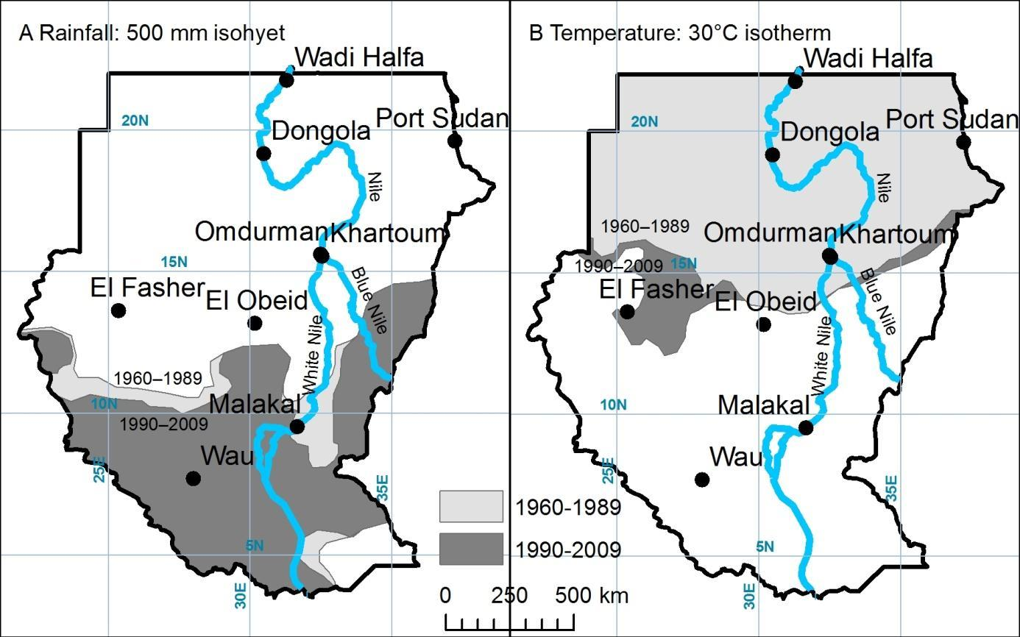

Answer: 2 marks: 1 mark for isohyets, 1 mark for isotherm.
It will be visual judgement for quite generalised lines but half marks may be awarded for lines that approximate to the actual lines.
For the isolines the areas have to:
- ‘Move’ towards the right direction,
- Follow some topography (hills, mountains, river valleys),
- Have an isohyet in south-western part of the country,
- Separate isohyets for Darfur region,
- Excellent if student could consider the uneven time periods:
NB! 1960–1989 is 29 years
1990–2009 is 19 years
2010–2039 is 29 years.
Original: figure 1 Source: ‘A Climate Trend Analysis of Sudan’: http://pubs.usgs.gov/fs/2011/3072/pdf/FS2011-3072.pdf (see below).

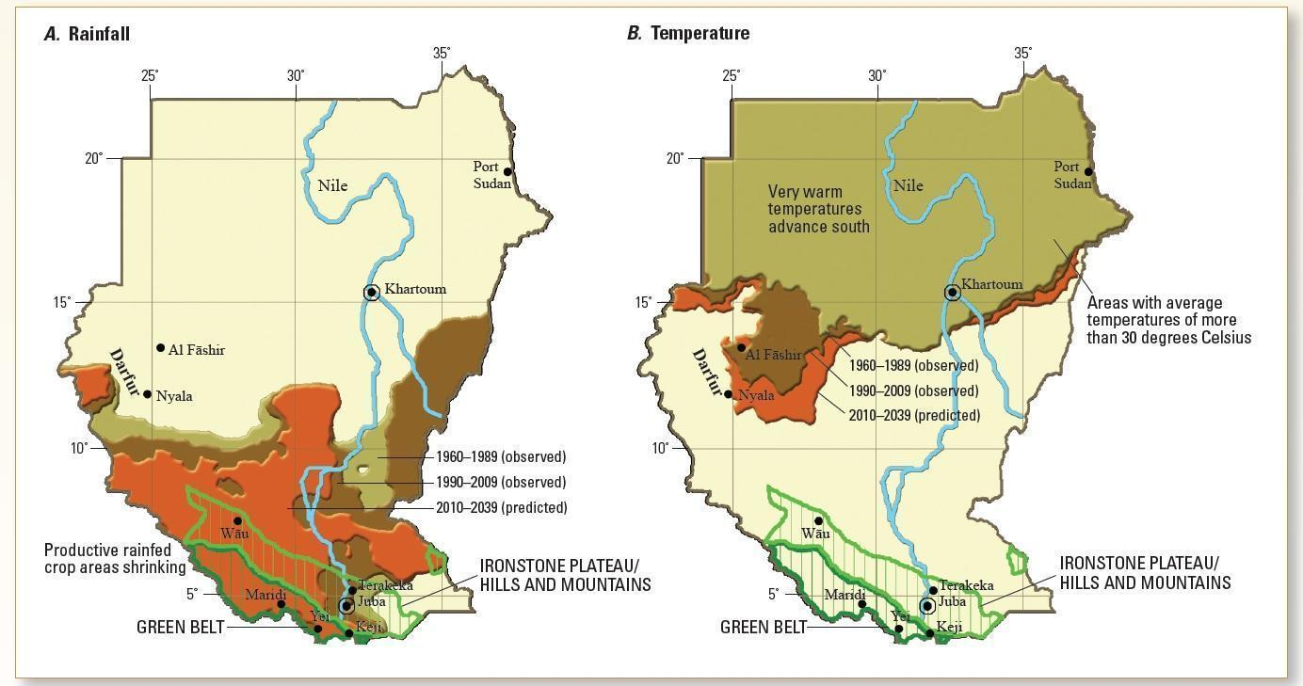

Figure 1. Climate change in Sudan. A, Average location of the 500-millimeter rainfall isohyets for the years 1960–1989 (light brown), 1990– 2009 (dark brown), and 2010–2039 (predicted, orange). The green polygons in the foreground show the main crop surplus region (the Green Belt livelihood zone) and the agro-pastoral Ironstone Plateau and Hills and Mountains livelihood zones. B, Similar changes for the 30 degrees Celsius isotherm. Areas north of this line are very hot; this intense heat makes plant growth and pastoral livelihoods difficult.

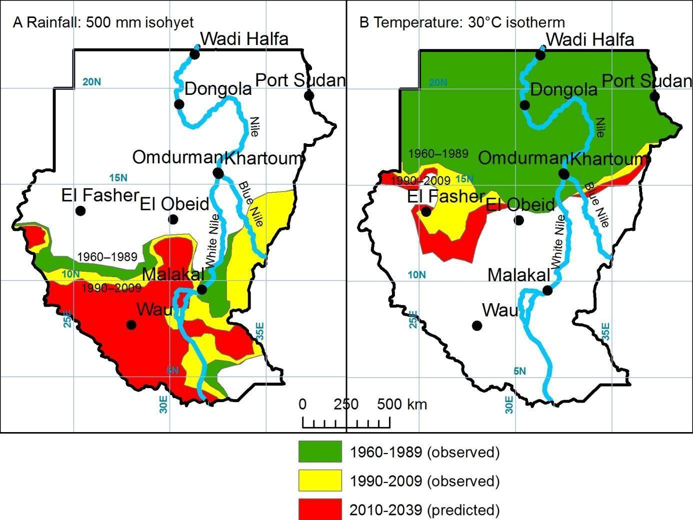

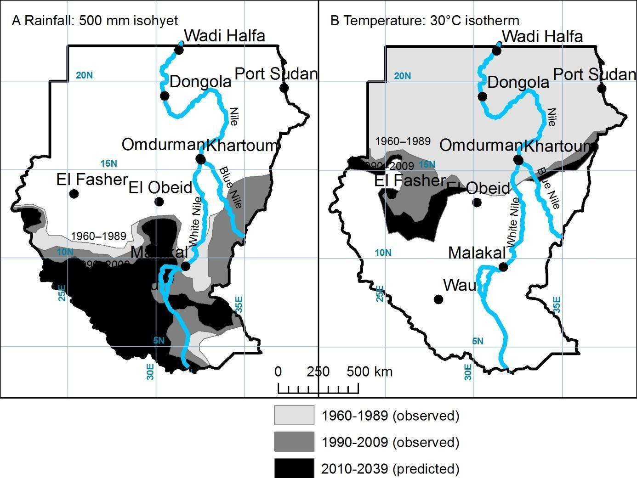
Section F: World Development

2m 1. Study Resource Booklet Sources F1 and F2 graphs.
Compare the relationships between the indicators of development shown in the 2 graphs.

Graph 1:

Graph 2:

Answer: 2 marks.
- Graph 1 shows a positive relationship between the 2 indices that is to say as income per person increases so does the amount of energy.
- Graph 2 shows a negative relationship. As the number of doctors per thousand increases so the rate of child mortality decreases.

5m 2. Complete the table below to make a ranking of development based on the 6 different indices for the 16 selected countries. Each of the indices has been ranked using the 5 divisions of the key shown below the maps. The rankings for Life expectancy, Infant mortality, Food supply, Availability of drinking water and Gender-related illiteracy have been completed for you.
- Complete the ranking for Literacy using the key to the Atlas page 193 map 4 “Literacy”.
- Sum the ranks for each country.
- Using the sum of rankings column create 4 categories of development and use this to complete the map to show the variation in stages of development of the 16 countries.

Answer: 5 marks:
1 mark for getting Literacy ranking correct,
1 mark for sum of rankings,
1 mark for the categories of development (making the 4 categories systematically),
1 mark for correct shading of countries,
1 mark for a map title and key.

The map produced must be a choropleth map. The students can use shading using only one colour or several colours as long as there is a gradation that means the countries in the lowest category have the lightest shading and the countries in the highest category have the darkest shading.

 | Life expectancy | Infant mortality | Food supply | Availability of drinking water | Literacy | Gender-related illiteracy | Sum of rankings | Categories of development (map key)
Argentina | 4 | 3 | 5 | 5 | 5 | 2 | 24 | 3
Brazil | 4 | 3 | 4 | 3 | 3 | 3 | 20 | 3
Bolivia | 3 | 2 | 3 | 3 | 3 | 1 | 15 | 2
Canada | 5 | 4 | 5 | 5 | 5 | 3 | 27 | 4
South Africa | 2 | 2 | 5 | 3 | 3 | 1 | 16 | 2
Mali | 2 | 1 | 2 | 1 | 1 | 1 | 8 | 1
Egypt | 4 | 3 | 5 | 4 | 2 | 1 | 19 | 2
Uganda | 1 | 2 | 2 | 4 | 2 | 1 | 12 | 1
France | 5 | 4 | 5 | 5 | 5 | 3 | 27 | 4
Spain | 5 | 4 | 5 | 5 | 5 | 3 | 27 | 4
Ukraine | 3 | 3 | 5 | 5 | 5 | 3 | 24 | 3
Norway | 4 | 4 | 5 | 5 | 5 | 2 | 25 | 4
India | 3 | 2 | 3 | 3 | 2 | 3 | 16 | 2
Iran | 4 | 3 | 5 | 4 | 3 | 1 | 20 | 3
Nepal | 3 | 2 | 3 | 3 | 2 | 1 | 14 | 1
Laos | 3 | 2 | 3 | 2 | 2 | 1 | 13 | 1

 | Life expectancy | Infant mortality | Food supply | Availability of drinking water | Literacy | Gender-related illiteracy | Sum of rankings | Categories of development (map key)
Mali | 2 | 1 | 2 | 1 | 1 | 1 | 8 | 1
Uganda | 1 | 2 | 2 | 4 | 2 | 1 | 12 | 1
Laos | 3 | 2 | 3 | 2 | 2 | 1 | 13 | 1
Nepal | 3 | 2 | 3 | 3 | 2 | 1 | 14 | 1
Bolivia | 3 | 2 | 3 | 3 | 3 | 1 | 15 | 2
India | 3 | 2 | 3 | 3 | 2 | 3 | 16 | 2
South Africa | 2 | 2 | 5 | 3 | 3 | 1 | 16 | 2
Egypt | 4 | 3 | 5 | 4 | 2 | 1 | 19 | 2
Brazil | 4 | 3 | 4 | 3 | 3 | 3 | 20 | 3
Iran | 4 | 3 | 5 | 4 | 3 | 1 | 20 | 3
Argentina | 4 | 3 | 5 | 5 | 5 | 2 | 24 | 3
Ukraine | 3 | 3 | 5 | 5 | 5 | 3 | 24 | 3
Norway | 4 | 4 | 5 | 5 | 5 | 2 | 25 | 4
Canada | 5 | 4 | 5 | 5 | 5 | 3 | 27 | 4
France | 5 | 4 | 5 | 5 | 5 | 3 | 27 | 4
Spain | 5 | 4 | 5 | 5 | 5 | 3 | 27 | 4

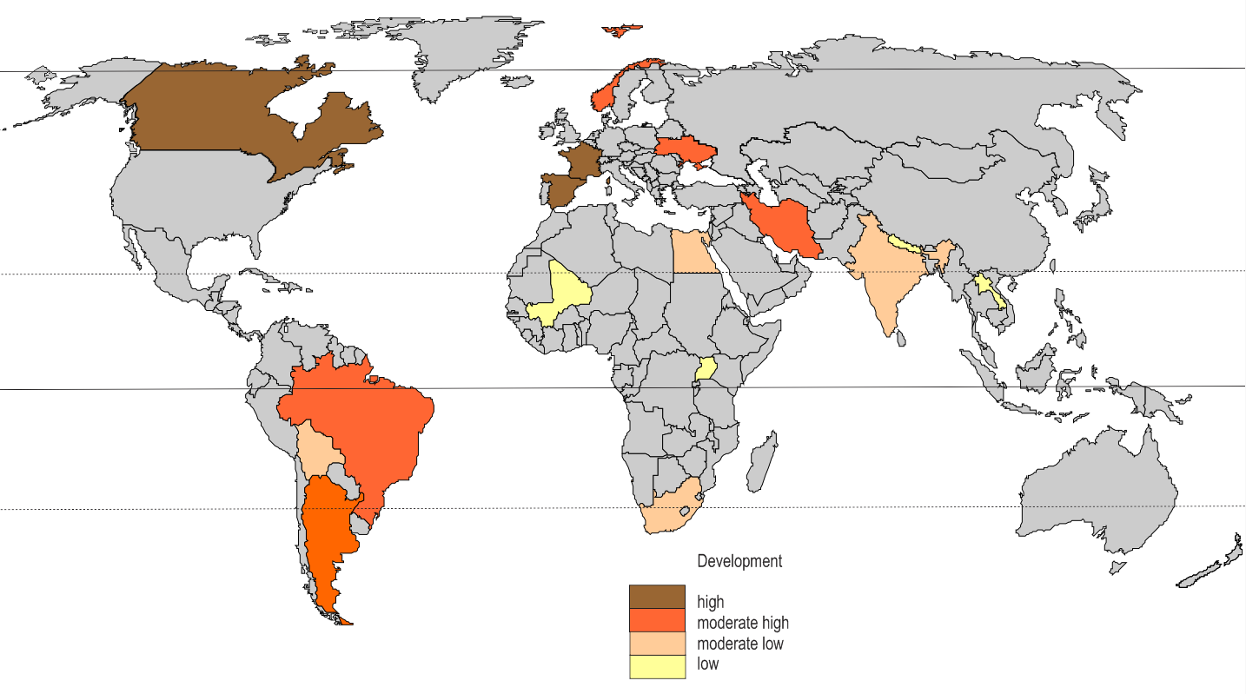

4m 3. Complete the table below by suggesting a reason for how each of the following factors:
- Dependency and a colonial past and
- World trade and globalisation
has contributed to those countries with the highest levels of development and those with the lowest levels of development.

Answer: 4 marks.
 | Dependency and colonial past | World trade and globalisation
Countries  with  the  highest  levels  of  development | Most countries built their economy on cheap raw materials from the colonies and profits from trade. Now multinational companies based in more developed countries also rely on past colonies to provide cheap labour and raw materials. However there are some exceptions, e.g. Switzerland who never had colonies. | These countries have a higher reliance on manufactured goods with a higher value and more steady prices.  These countries are better served by transport routes and are better connected to each other.  Countries with highest development have more service industries and more research and development which needs better global connections.
Countries  with  the  lowest  levels  of  development | The colonial system supports dependency. To buy goods these countries borrowed from the colonial powers which led to large amounts of debt.  These countries also exported their raw materials to their colonial powers and were unable to use them themselves to build their own economies.  These countries struggle to get out of the debt cycle. | These countries rely on the production of raw materials and agriculture for their income with fluctuating prices.  They have a relatively small share of world trade and rely heavily on primary product for export earnings.  The countries on the maps are landlocked countries with difficulties for trade and links with overseas countries.

4m 4. Discuss the causes and the consequences of development gaps within countries.
Illustrate your answer with examples.

Answer: 4 marks: 2 marks for causes and 2 marks for consequences.
Students must refer to causes and consequences in their answer to achieve full marks.
Causes:
- Core/periphery concepts where capital cities attract investment and become more affluent than surrounding areas.
- Urban /rural differences where there are declining job opportunities in the countryside because of more efficient farming techniques; or remote areas have poor communication links e.g. Areas of China and India.
- Areas become rich because of the growth of industry and wealthy cities e.g. Northern Italy.
- Coastal areas are more accessible and interiors are difficult to reach and develop because of climate or vegetation, e.g. Australia or Brazil.
- Gaps within cities because of the caste or religion of different groups, e.g. the caste system in India.
Consequences:
- Migration of people from poorer areas to more affluent areas e.g. rural to urban migration in UK.
- Poor transport links in peripheral areas or remote areas e.g. northern Canada, interior of China or Australia.
- Area of rich and poor housing within cities which lead to inequalities, sometimes protested about in riots.
end

